Professor: Francisco Neville

Class: CS 3380

Title: GameDev Playtest project

**Ludo Prototype Description**

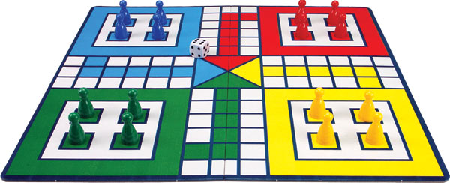

**Introduction**

**Team Info**

**Members:**

* **Franck Dosso : Music design/ director**
* **ThankGod Ofurum: Concept artist/ modeler**
* **Leandro Aguiar: Game designer/ mechanics**

**Idea**

Project: Ludo is a two-dimensional, multiplayer, virtual board game based on the real-life game of Ludo or, as called in America, ‘Sorry’ where players compete against each other by moving their chips all across the board in an effort to be the first to get all the chips across the finish line. The idea behind implementing a variation of this already established game is not only to provide players with a sense of familiarity by making use of the platform, concepts and title they’re already used to, but also to engage them by making use of interactive sounds and music during gameplay, and to redefine their expectation of the game of Ludo therefore making them think harder through the use of various mechanics such as deep pits and black holes.

**Overview**

Ludo is a virtual board game that includes two to four players in which each player race their four colored pieces through a path according to their die rolls. At the start of the game, each player possesses four pieces of their prefered colors that are placed in the player homeground,

Each player takes turn to throw out a dice trying to play a six in order to get one of his pieces from his homeground to the starting line. Once at the starting line the player’s piece moves forward according to the result of the die. If a player plays a six, he has a choice between moving one more piece out of the homeground or moving it forward. The goal of the game is to get all your pieces across the finish line. However in this virtual ludo game, new challenging rules have been added such as deep pits(get your piece stuck until you play six) and black holes (return your piece to your homeground). The game includes two types of fun, that are challenge and submission. It is considered to be appealing to submissive players because it requires considerable amount of repeated dice rolling. Also it is challenging since you are competing with another opponent and that opponent can prevent you from achieving your goal by taking your piece away.

**Audience**

Challenging players

Submissive players

Ages 4 and up

**Sound**

To give more aesthetics to the game, we generated sounds to the intro menu whenever the user clicks on an option. During the gameplay, a theme song has been added to avoid the game to feel dull. In order to make it more interactive, different sounds would be generated whenever an action is taking place such as moving pieces, black holes, deep pits...Also a computer sound (virtual assistant) has been introduced to help the user go through various stages of the game.

**Key terms**

* **Deep pits :** Gray squares that can get your piece stuck until you play a six to unstuck them.
* **Black holes :** Black holes that return your piece into its homeground.
* **Die :** The die will determine your moves throughout the game.
* **Pieces:** Each player possess the same amount of pieces and they are the main actors of the game.
* **Finish line:** The line to cross to win the game.
* **Homeground:** The location your pieces reside as soon as the game starts.

**Gameplay**

Player is asked to place deep pits then black holes. Once that is done the player is then asked to roll the die. If the player fails to play six, the next player takes the turn to roll the die. As soon as a player rolls a six, he can then move one of his pieces out of the homeground to the actual game field. if a player gets his piece into a deep pit, that piece gets stuck until he plays a six. In case a player gets his piece in a black hole, that piece will automatically return to the homeground. In order for a player to win, he has to get all his pieces across the finish line.

The mechanics adopted were basically clicking to move and pressing enter to roll the die. During the game, instructions are given by a virtual assistant.

**Configuration**

In the intro menu, the user has the possibility of choosing the number of players. A future improvement is letting the player chose the number of pieces each player should possess, and how many of them need to cross the finish line to win the game. The game itself is prepared to work with those configurations. However the intro menu is not fully functional yet, so to modified other parameters a text file must be edited or there is still the option to run the game without the intro menu, in this case the player will be prompted to type the parameters.

**Variations**

The variations added to the game were the introduction of deep pits and black holes. Another rule change was the remotion of the extra turn the players have after rolling a 6. These modifications help to make the game a little less random and also more challenging. However after playing the game we realized that it was to hard and that could be disappointing, especially for the kids. To compensate for the extra challenges added, we also changed another rule of the game. When the player gets his/her pawns to the final path, the one with the player’s color, he/she is now allowed to move it further no matter the number rolled, instead of needing to roll the exact number to cross the finish line.

**Credits**

<http://www.chiquiplanet.com/board_games/ludo.html>

SoundBible.com and youtube.com

<http://audio.online-convert.com/convert-to-wav>

<http://www.fromtexttospeech.com/>

<https://www.pygame.org/docs/ref/mixer.html>

<https://www.pygame.org/docs/ref/music.html>

**Similar games**

Pachisi

An old board game from India which is very similar to Ludo. The players need to move their pieces around the table and then race then to the finish line.

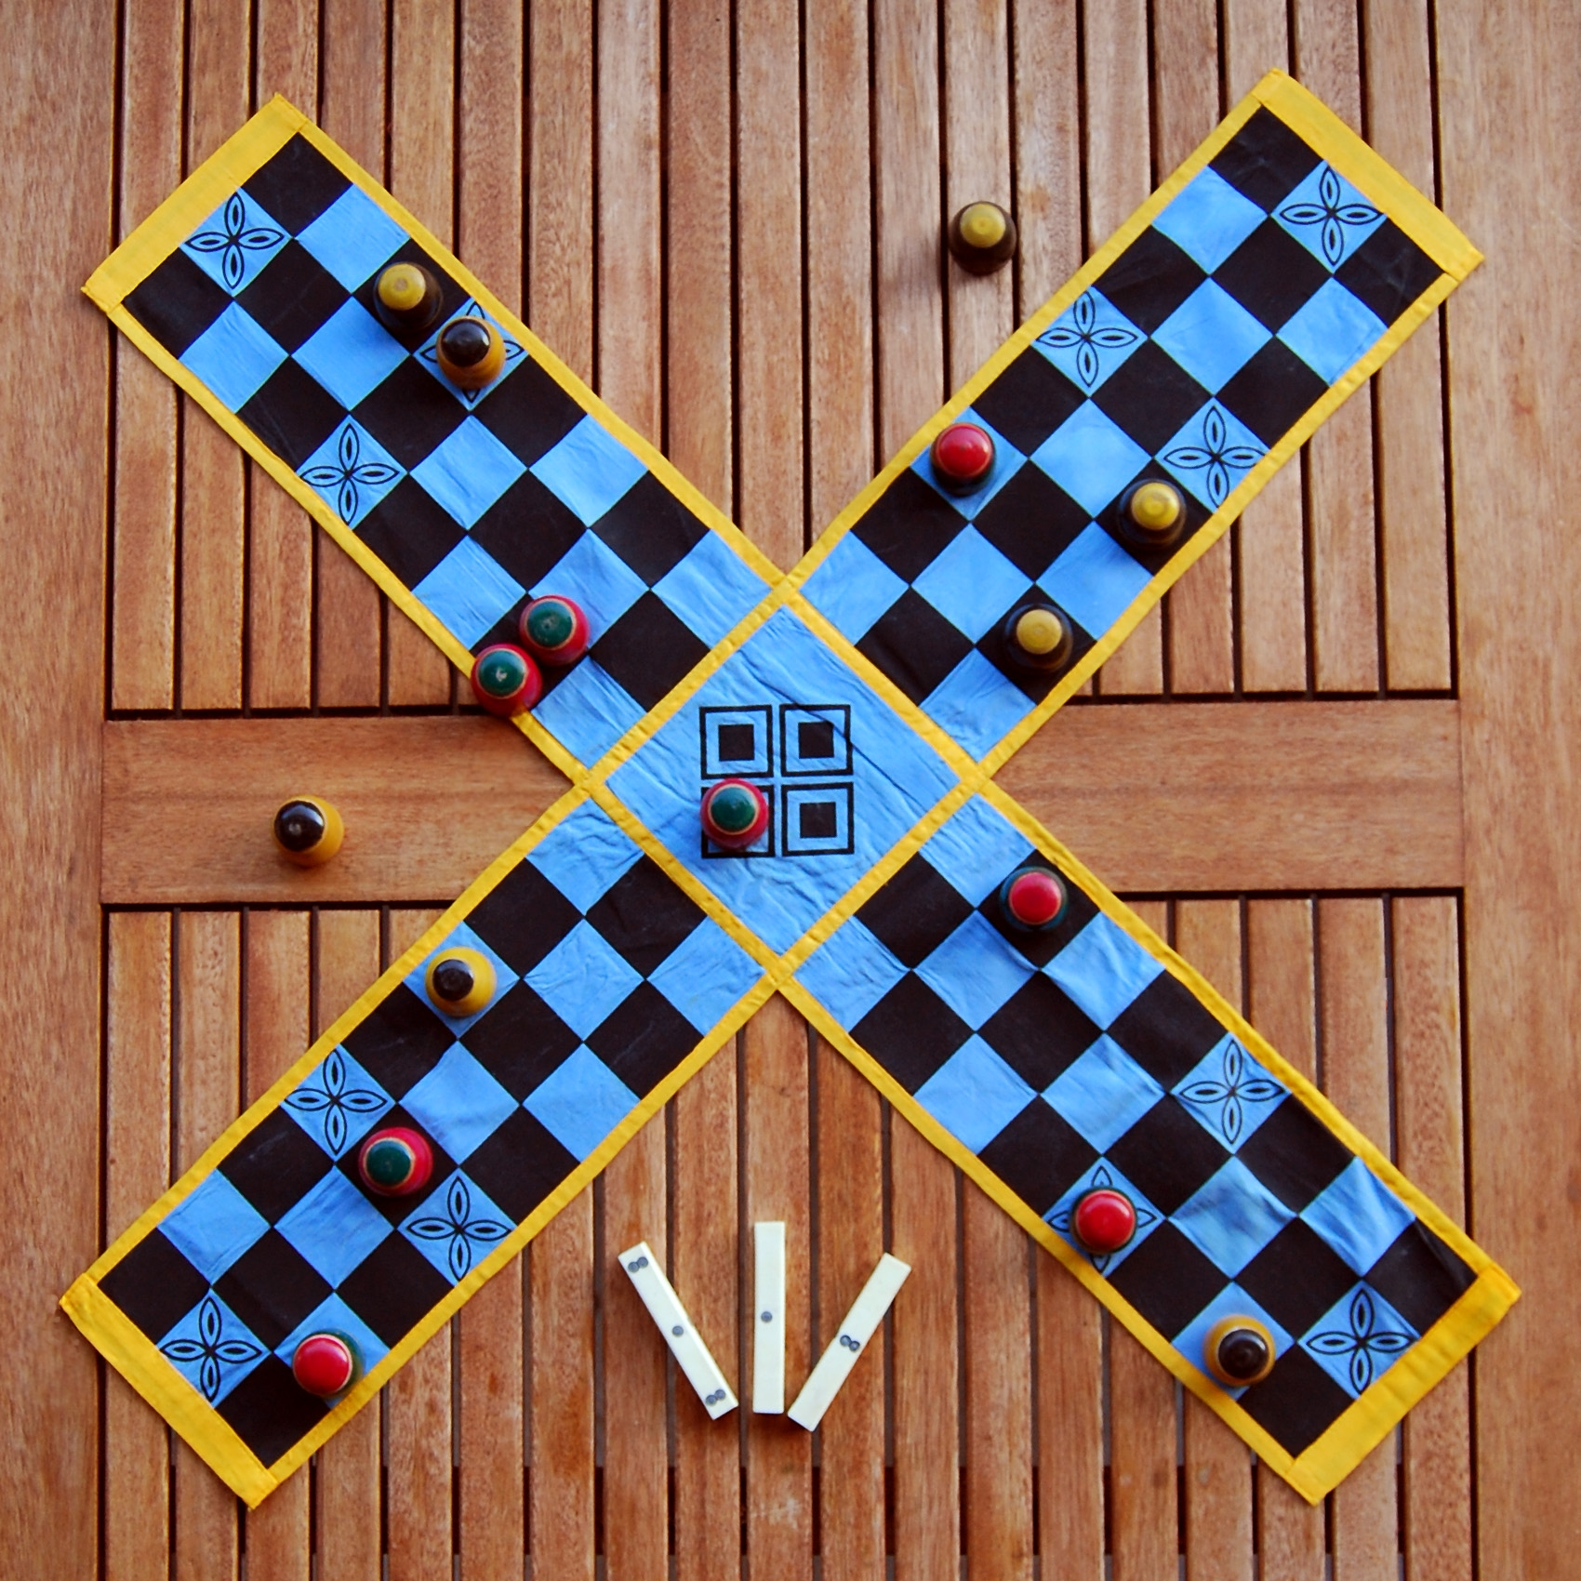

Uckers

This game is similar to Ludo. But it includes many variants, some of which are: more than one dice, and up to six players.

